Whither Statistical Metadata?
Andrew Westlake

The use of metadata as description of statistical datasets has been with us for some time, and the value of this approach is demonstrated by the success of initiatives for metadata standards, such as triple-s, SPSS Dimensions and DDI. The need to support discovery of resources and services over the internet has widened interest in and use of the term metadata, focussed by initiatives such as the Dublin Core, the (derived) UK Government Metadata Standard (e-GMS) and ISO-11179.
These standards and structures are now being influenced by more formal ideas from IT systems design. The recent proposals from SDMX and (version 3 of) DDI are strongly influenced by object-oriented design principles, using UML as the specification medium. This extends the specification beyond the structure of the information represented to include the formal representation of the semantics and functionality that are needed in order to use the metadata.
These proposals cover information about the data capture process (including sample and instrument design), about the structure and location of datasets (including coding), and the exchange of data (with metadata) in micro or macro form. The Opus Project has attempted to go further than this and represent the statistical models used in the analysis of data, and thus to provide a link back from conclusions and results based on statistical information (evidence) to the assumptions and data used.

Statistical meta-data, modelling, UML, system design, standards

Whither Statistical Metadata?

Applications with Structure
The future of Statistical Metadata (and metadata in general) does not lie in further amateur attempts to design XML data structures for some particular problem. Rather, it lies in a professional approach to system design and software development, producing metadata-aware applications that can use, capture, present, manipulate and re-use metadata and the associated resources which it describes.
We have had innumerable proposals for metadata systems and standards over the past decade, but few have produced anything usable or lasting. The few that have been successful have either been extremely simple in structure and concept – such as triple-s[1] for data and label exchange, or the Dublin Core[2] for resource discovery – or have involved very significant investment – such as the proprietary Dimensions system from SPSS, complete with an API and its own version of Visual Basic.
Other initiatives have produced valuable insights into the requirements for metadata in statistical applications, but little in the way of usable functionality. For example, in the field of questionnaire and instrument design, the IQML project[4] and the QEDML system[5] (both presented, along with several others, at previous ASC conferences) provide many useful ideas about the representation of questionnaires and the data capture process, but neither has produced a direct legacy – IQML came to a natural end, so that its influence was always going to be indirect, and the QEDML web site has not been updated since 2004, in spite of very considerable enthusiasm about its potential.
This is not the right point for an exhaustive discussion of such initiatives, but there are many that could be mentioned, often with considerable merit but with only indirect influence on actual metadata practice. A few exceptions are discussed later.

Quality and Use
The purpose of metadata is to support the use of actual statistical data, or some other resource. For metadata to be used it must be both useful and useable. To be useful it must be pertinent to the task for which it is to be used, and must also be of adequate quality for this task. Where metadata (or any other resource) is not used there is no incentive for those collecting it to maintain quality, which in turn makes it less likely that it will be used, a vicious circle. We need to break that circle.
But usefulness is not enough to ensure usability. Reading extensive documentation sometimes provides some information but is rarely the best way to use metadata to support some task. This is particularly true when the metadata is presented as a raw XML document. Instead we need metadata-enabled applications which make use of metadata to simplify or enrich the functionality of the primary task of the user.
In the same way, metadata capture should not in general be a manual task. Metadata is rarely (perhaps never) new information, it is just ancillary information that an adjunct to some other task. So the process of performing the initial task should automatically capture the related metadata. For example, the design of a questionnaire (with all its wording, conditions, filters, skips, fill-ins, etc.), in a suitable design program, already contains all the metadata about the questionnaire structure that might be needed to inform later analysis of data collected from that questionnaire. We just need to expose that information in a way that can be used in other contexts. And the exposure makes it possible to enhance the design process as well, for example by importing questionnaire fragments from a Library or another questionnaire (perhaps designed in a different application).
Similarly, sample design specifications, or information about data transformations or adjustments can be captured automatically for subsequent use. Quality is maintained through such automatic capture, and, where additional manual input is needed, the quantity (the additional workload) is minimised, relevance should be clear, so quality should be high.

Design by Structure
The idea of metadata aware software is not new. Virtually all survey and statistical packages from SPSS onwards include a specific data dictionary (or codebook) which is used internally, and can sometimes be accessed externally. In the early 1980’s the World Fertility Survey was using processing facilities built around a data dictionary system (as were others), and a comprehensive description of such an integrated metadata-aware statistical processing system was presented by Jean-Pierre Kent[6] in an SSDBM paper of 1997.
Many designers of statistical and related systems have internal components which involve explicit representation of metadata, and its use within the system to enhance and facilitate the user experience. There is no direct incentive for developers to invest effort in the design of interfaces to expose this information to other applications, whether complementary or competitive. Such pressure has come from users or independent developers (often academics), and the simplest solution has been seen as the design of an exchange file format, for which import and export facilities can easily be appended to existing software.
The problem with this approach is that different developers use different concepts within their systems, or interpret and implement the same concepts in different ways and with different details and assumptions. The designers of the triple-s interchange standard recognised this problem and chose to take a highest common factor (HCF) approach. This results in a minimalist standard that is very limited in scope, but is usable in full by all the (initial) participating systems. This achieves the objective of moving datasets between supporting systems, but means that the user may have lost some information that was in the source system, because it is not available or is represented differently in the target one.
The independent approach has been to try to define a separate ‘standard’ as a super-set of concepts to which all systems can subscribe. Where this is done as a union of facilities from an existing set of systems there is a danger of too much detail. This can lead to ‘gothic castles’, which contain huge amounts of intricate (and sometimes interesting) detail, but no obvious overall structure. The more favoured approach (which was supported by a number of European 4th and 5th Framework projects through Eurostat) is to perform a more generic analysis and to identify concepts and principles that need to be represented, then to develop a metadata design based on these, using object concepts of inheritance and specialisation to handle details.
Most initiatives in this area (and not just within statistics) seem to concentrate on defining the data structure needed to store instances of metadata, usually as an XML document – hence the early derogatory remark in this paper. While defining a suitable structure is an essential part of the design process, it is only a step on the way to producing metadata-aware applications, and while XML is an essential tool for the exchange of metadata instances between independent applications, an XML Schema is not an adequate medium in which to specify processing functionality. Many proposals for standards do include some ideas for actual applications, but this is usually seen as a separate phase following after the structural definitions, and in consequence very little gets done.

Design for Use
The purpose of metadata is to support other tasks. So the design of a metadata system should be related to the design of applications which are metadata-aware. The functionality provided to support the use of the metadata is more important than the structure used to store it. This leads to the conclusion that metadata design should be seen as an instance of the more general systems design process, and should take advantage and make use of progress that has been made in that area.
A great deal of effort in recent decades in the Computer Science domain has been spent on the development of methodologies to support the development of application software. Most of this has been focussed on the Object-Oriented approach, and within statistics we have the application S (and R) as an example based on these ideas. A number of different methodologies (procedural specification methods for software development) grew from this base, followed in the late ‘90’s by a consolidation and standardisation effort that produced UML, the Unified Modelling Language[7]. UML is now in version 2.
UML is widely supported by tools based on the standard, from initial design through to implementation of applications. It covers all stages and aspects of system design, so that (at least in theory) it is possible to completely specify an application in UML, and then have that design automatically translated into an executable program in a suitable language. In that sense it is language-independent, though it is probably most frequently used with Java.
Designs in UML include data structures (as needed for internal use in applications as well as for exchange), but also cover the behavioural and procedural aspects of applications. Thus, when thinking about the information structures that are needed for a metadata application, it is also possible to specify the behaviour and processes that are expected to be associated with this information. UML specifically supports the idea of abstraction, so it is not necessary to immediately specify all the details of some process: it is sufficient to specify just the outline, with further details supplied later at an implementation stage.

Conclusion
Metadata needs to be used, and this use takes place in metadata-aware applications. So the design of metadata systems should take place in the context of (at least some of) the applications which will make use of such a metadata resource.
UML is an ideal medium in which to specify the design of such metadata systems, as it allows behaviour and process functionality to be designed, alongside the data structures needed to represent the metadata resource.
A number of recent metadata proposals have been designed in this way, and demonstrate the feasibility of this approach, specifically the SDMX[8] (Statistical Data and Metadata Exchange) standard for the exchange of aggregate data between statistical authorities, and Version 3 of the DDI[9] (Data Documentation Initiative) Codebook standard for documenting data resources.

Coverage of Statistical Metadata
As we start to think more specifically about the tasks for which statistical metadata can be used, we also need to think more widely about the areas of statistical processing that should be covered.
Statistical metadata started with data documentation in codebooks, containing label information about variables and codes within a single dataset. Extensions to this that have been implemented include multiple datasets, aggregated data, sample design and responsibility links. Specifications for derived variables and complete questionnaire specifications have also been attempted.
As part of the MetaNet[10] project, Froeschl and colleagues[11] produced the first version of UMAS, a Unified MetaInformation Architecture for Statistics, intended to cover all aspects of statistical processing. This contains many good ideas, but is an ambitious project that needs further work.
The Opus Project[12] also extends metadata well beyond data description, though with a more specific objective. It attempts to document statistical analysis processes based on statistical models and represent the statistical models used in the analysis of data, and thus to provide a link back from conclusions and results based on statistical information (evidence) to the assumptions and data used.

Why Metadata?

What is metadata?
Bo Sundgren claims to have coined the term ‘metadata’ in his PhD thesis of 1973, but the term did not come into general use until considerably later. It was generally used by people working with statistical data by the late ‘80’s, but it was at least another 10 years for the blank expressions to disappear from the faces of people from most other disciplines.
In the Metanet project we developed the following definition of statistical metadata.
Statistical Metadata is any information that is needed by people or systems to make proper and correct use of the real statistical data, in terms of capturing, reading, processing, interpreting, analysing and presenting the information (or any other use). In other words, statistical metadata is anything that might influence or control the way in which the core information is used by people or software.
It extends from very specific technical information, used, for example, to ensure that a data file is read correctly, or that a category in a summary table has the right label, or that the design of a sample is correctly taken into account when computing a statistical summary, right through to descriptive (intentional) information, for example about why a question was worded in a particular way or why a particular selection criterion was used for a sample.
Thus, metadata includes (but is not limited to) population definitions, sample designs, file descriptions and database schemas, codebooks and classification structures, processing details, checks, transformation, weighting, fieldwork reports and notes, conceptual motivations, table designs and layouts.
With the rise of the Internet the concept of meta-data has become much more widely recognised. The major factor for this (though not the most interesting application) has been the Dublin Core standard for recording descriptive information about other resources. This has been taken up as an enabling technology for intelligent searches on the web.

What is metadata for?
This is probably a more important and interesting question than the question about the basic definition.
Statisticians usually start with data description – the set of labels for annotating output from analysis of a statistical dataset. This usually includes names and labels for variables and labels for codes within the dataset, and is sufficient (for an informed user) for the creation of reports and the transfer of datasets between applications.
A usual and frequent extension is to support secondary uses of original data by other analysts. Then the metadata has to help the user to understand the data. Information is needed about the context and provenance of the data. This can include proper understanding of the meaning and intention of words in codes and questions, the methods of data collection, etc.
As data usage becomes more complex – for example, the integration of data from multiple sources, or more complex statistical analysis and modelling – the demands on the meta-data increase, with the need for deep understanding of coding systems and mappings, and for confidence in the quality of the underlying data and in the manipulation and analysis methods used.

Metadata supports use
From the perspective of use, we can formulate a definition more focussed on the way in which the meta-data supports the use of the underlying resource.
If I have created a dataset, the metadata for that dataset is the information that I need to give to you for you to be able to use the dataset correctly for your chosen purpose (or to realise that the dataset does not support that use).
More generally, metadata is the information that the owner of a resource needs to supply to potential users of that resource, so that they can use it correctly.
Resource
Owner
Users
Meta-Data
Figure 1. Meta-data and Users

Metadata as a resource
With this approach to metadata we need to move the focus away from the underlying structure and on to aspects that support its use. Firstly the correct content must be available, and secondly the correct functionality must be supplied to support the processes in which the metadata is used. For content we need to address issues of the structure that is to be allowed for the representation of the required information, and for the functionality we need to consider the processes in which the metadata will be used. The metadata should be seen as a resource to be used, and the methods and means of use are as important as the specification of the structure of the content of the resource.
This approach echoes developments that have been taking place in recent years with regard to the Internet.

What is a resource?
Significant effort has been invested in recent years to extending the way in which the Internet is used. Its underlying ability to deliver contend has been recognised some time but the move is address is the issues of delivering functionality as well. The first within this direction is in the context of Web services. The idea here is that specific functionality can be centralised by some service provider on Web, and users can then communicate with this service, using an appropriate protocol, to make use of the processing methodology that is supplied. The second idea is the one often referred to as Web 2, which attempts to associate much more understanding (semantics) with objects and resources found on the Web. This is clearly closely related to the Metadata ideas that we are discussing.
This approach raises significant and deep questions. What is a resource? What is a service? How I these resources and services identified and used?
The answers to these questions are well beyond the scope of this paper, but it suffices to say that solutions are being discovered and developed within the computer Science and Internet domain. Protocols and standards have been developed, at both generic and specialised levels, and are now supporting many activities on the Internet. Many are in specialised areas and so not widely appreciated. Two that are very familiar to most Internet users are the use of search engines, such as Google, and payment schemes for authorising purchases over the Internet.
The used of Web services requires considerable trust between the client and the server. This can only be achieved when there is great precision and formality in the specification of the interaction between them. Standards are essential in this, and must address understanding and interpretation as well as structure.
Potential client systems need to be able to discover the existence of services, and to discover the standards required for communication with them. To this end there has been a parallel development in the concepts of registries and repositories. A registry holds links to services that have agreed to meet specific standards, and can be queried to discover specific servers offering particular types of service. A repository is similar to a registry, but is likely to contain fewer types of resource and more actual content. A registry can solve the discovery problem for particular services, but does not of itself ensure common understanding between the client and the service of the detailed implications of the service specification.

The object paradigm
Underlying most recent development work is the object-oriented approach to systems. This was developed some time ago and came into prominence in the late 1990s. It is fundamental to most current programming methodologies, but also is applicable in any system design context.
Within this approach, the focus is always on an object. This is a collection of information, which has a type, and which has behaviour associated with it. The general type of an object is called a class, and this determines the general form of the content of that type of object, and the functionality associated with it. Instances of an object contain actual information specific to a particular resource. The content of an object is generally a set of other things, including both other objects and primitive values.
Object instances have individual identity, so can be uniquely identified, and can respond to requests to perform tasks. These can be specific tasks related to the type of the object, or more general tasks such as reporting an object's own type, or listing the tasks which it can perform. Object types (classes) can share structure and behaviour through inheritance, in which one type of object is defined as a specialisation of another, usually with some enhancement to particular areas of structure or behaviour.

Object modelling
The object paradigm sets out various principles about how systems should be designed. Following from this a number of methodologies were proposed for the process of system design (or modelling, the computer science use of this term). These different proposals were finally brought together in the Unified Modelling Language (UML), which has continued to develop and is now at version 2.1.1. A number of design and development applications (and environments) have been created which use UML: as their underlying model, and these can allow designs (models) to be exchanged.
UML is a very extensive specification, and is not easy, either to learn or to use, but it is capable of producing precise specifications of significant systems. It is not entirely water-tight, but used carefully it can go a long way towards the production of an unambiguous specification of the structure and behaviour of a system. It is thus an important tool in addressing the problem of communicating understanding between the authors and users of systems.
Specifications in UML are formally structured, so can be transformed into other forms. For example, it is possible to generate executable code (programs) from certain types of carefully written UML specifications. It is also possible to transform the structural specifications in a UML class specification into the schema needed to create equivalent structures in XML. This facilitates the exchange of information about specific resources between different applications or implementations based on the same UML specification.

XML for Exchange
XML is an extremely important technology for object systems, because it allows complex structures of information to be expressed as linear text in an XML Document. This is sometimes referred to as serialisation of object structures. Text documents are easy to move around over communication systems, so XML solves the problem of the transport (or exchange) of object structures between systems, whether different applications or different instances of the same application in different places.
The allowed content for a particular type of object in XML is defined using an XML Schema. The system is powerful and flexible and allows considerable detail to be specified about what is allowed at various points within a specific type of document. Even more generality is possible in UML, and because UML covers the design of complete systems it can also be used to specify the behaviour or functionality associated with particular elements of the object structure – this is not possible in XML schema.
It is thus recommended that UML be used to define the structure and behaviour of systems (including metadata systems), and then to generate from the UML the XML specifications needed to control the exchange of information about specific resources between systems, in the form of XML documents.

Levels of abstraction
Different types of application and context need different levels of abstraction in their conception. In dealing with practical problems we need to operate at a very concrete level, but when designing functionality for these operations it is often better to work at a more generic level. For example, users of the metadata about a dataset want to know about the meanings of the codes used within that particular dataset. However, designers of programs that use the metadata need to think more generically about what a code is and how it can be used appropriately. Similarly, those responsible for the integration or for the comparability of information from different data sources need to think at a more generic level about code sets, about structures of coding systems, about the concepts that underlie the questions asked, and so on.
There is an even more abstract level that is often needed. This relates (among other things) to the functionality and concepts that are needed to define things at the generic level. For example, with XML, the basic XML language is defined in a very abstract way, without reference to actual information resources. The XML language is used to construct XML documents, and some generic functionality is defined, regardless of the content of the documents. So software can read and write XML documents without needing to know the details about the content, and generic facilities support navigation through the structure, using the names of elements or their position. Similarly, a document can be displayed without knowing what it represents. In addition, the idea of a schema, with which to define the structure of a particular type of document, exists at this generic level. A schema then contains the specifications for the structure of a particular type of document, so this specification is at the intermediate level of abstraction. Actual instances of documents of this type (consistent with the schema) are the concrete level.
It is very important to be clear about the appropriate level of abstraction needed for the design or discussion of some structure or functionality. One of the most important outcomes of the MetaNet project was the realisation that most misunderstandings or confusion in discussions arose from a failure to recognise or agree on the level of abstraction appropriate for the context or application.

Model Representation in OPUS

Metadata for Statistical Models
The OPUS project was concerned with the integration of information from multiple sources, through the use of statistical modelling. A component of the project addressed the issue of recording what had been done (a complete audit trail), so that subsequent analysts could review all the steps taken, and so that users of results derived from the statistical models could (if so inclined) obtain information about the uncertainty associated with such estimates. We refer to these two areas as Provenance and Reliability.
Most of the rest of this section discusses (at a high level) the components of the structure that we designed. The following section shows some of the display functionality that has been implemented. The uses that this resource could allow include:
- Detailed exploration of the form of statistical model used, including the (conceptual) variables and parameters involved, and the relationships between these elements (both derived and stochastic).
- Exploration of the quality of the input data used, through links to the actual datasets used in model fitting.
- Investigation of details of the model fitting steps employed, including the software and algorithms used, plus progress and final states of iterative procedures.
- Exploration of the confidence associated with parameter estimates (in a classical analysis) or the posterior uncertainty (in a Bayesian context) at the end of fitting steps.
- Risk analysis for decisions based on results from the modelling, including sensitivity analysis to aspects of the model specification.
- General investigation of model reliability and sensitivity.
Implementation has so far addressed only the first of these uses, and that not to any deep level. Most of the others have not yet been elaborated.

Objectives for Data Structure
Our objective has been to design a structure (which we refer to as StatModel) for the representation of information about statistical models, together with appropriate functionality for the presentation of that information.
The data structure must include information about
- the structure of the statistical model used;
- the processing steps used to calibrate the model against data (model fitting);
- datasets used in model fitting steps;
- parameter estimates and uncertainty resulting from fitting (a model state);
- results derived from a model state
This information will come from other applications. Different applications embody different conceptual models of their methodologies and their application domains. Our aim with StatModel is to be sufficiently generic to be able to encompass these different views. This requires exploration of the mappings from application-specific views to the StatModel view.
Our immediate purpose for this information is to allow users to explore the specification of statistical models. However, some developers have suggested a need for a structure to allow the exchange of statistical models between applications, and we hope that StatModel may be a contribution to that.
We also hope that applications will want to use StatModel as their native structure for storing information about models and processes. So we allow for structural extensions to the model, both as new generic requirements are identified and so that applications can store information specific to their requirements.
When developing an understanding of an analysis domain it can be useful to store models that are incomplete, or that are defined at a level of abstraction above that needed for the computation of results. So the structure must not impose completeness rules unless they are always appropriate. Of course, this implies that applications using the structure must be able to check whether an instance of the structure is complete enough for the purposes of the application.
We are not attempting to produce a complete statistical metadata system, so assume that metadata and presentation functionality for other components (such as classification structures and dataset documentation) will be available through external links.

Users
Many users of statistical results have only limited understanding of statistical models and methodologies. For them, information about the statistical models needs to be presented in ways that relate to the reliability of the results for use in their working context, rather than the more abstract terms of the model itself. Furthermore, different domains build on different conceptual models for the form and description of relationships and dependencies, and an ideal presentation system should work within these.
In contrast, those who actually develop statistical models are more likely to have a good understanding of the more abstract concepts involved. For them a more generic presentation of model information may be adequate, or even preferred.
We thus envisage that significant use of the StatModel approach to support the use of statistical model results in a domain will require a presentation application that is specific to that domain. Such presentation systems are not too difficult to build using web-based methods. As an example, the Nesstar system [13] has been used in a number of large-scale dissemination projects to present basic statistical results and related materials to groups of users in specific domains.
We have concentrated in creating generic displays that can be used by specialists, and that can also be building blocks for the construction of more specific presentations.

Structures
The structure and semantics of the classes used to hold information about a statistical model are specified in UML using the hyperModel Workbench application [14]. The main components of this structure for a single model are shown in Figure 2, and are elaborated in [15]. Information about multiple models can be stored together and they can make cross-references.
A model must contain a model specification, which is where the variables, parameters and relationships which specify the model are stored (the structure of these elements is elaborated later). The variables correspond to the statistical idea of Random Variables, that is they relate to suitable data subjects (for whom actual values may be observable) but we are interested in the stochastic distributions of the values, not the values for individual respondents.
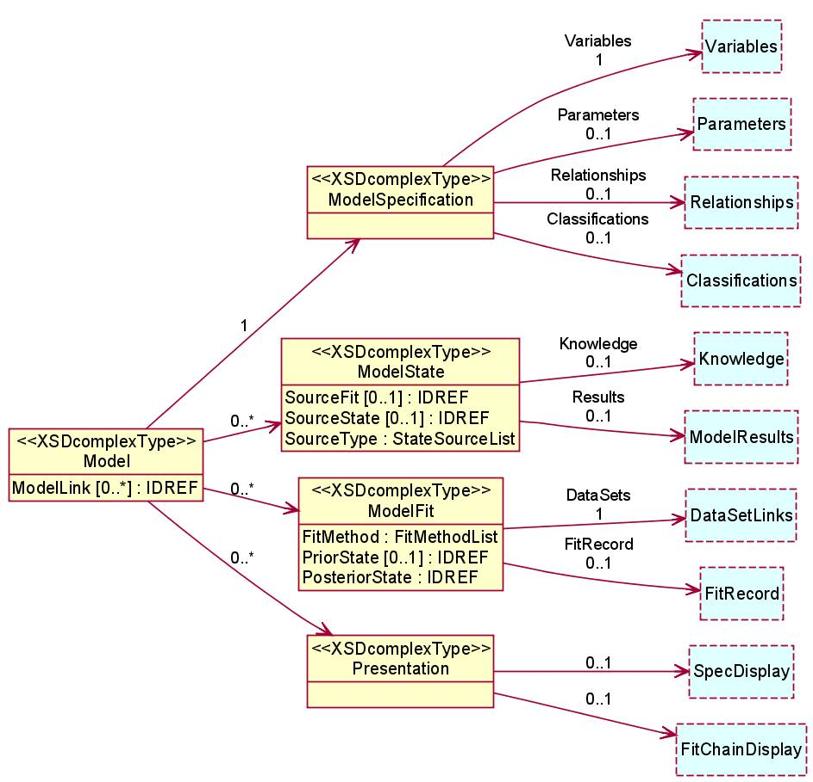
Figure 2. Main components of a model
Parameters are properties of the underlying system. They are real (fixed, though perhaps changing over time), but they cannot be directly observed. We extract evidence about them from data, but there will always be uncertainty about the true value. This uncertainty is represented by uncertainty distributions, which have the same mathematical properties as probability distributions, but a different interpretation.
At the early stages of development of a model it is sufficient to specify variables and parameters at a conceptual level. Their intention must be clear, so that influences between them can be identified, but details of their representation can be left for later. For example, a variable that relates to the income of a respondent should probably make reference to an appropriate definition of income, but does not need to be specific about currencies or whether the representation is exact or grouped. More measurement detail is needed when the details of the relationships are added, as these will include mathematical expressions.
Both variables and parameters can be array structures in which all cells are of the same type. Classifications are used to define the dimensions of such arrays.
Relationships specify how variables and parameters influence each other, and can be deterministic or stochastic.
A Model State contains knowledge about all the parameters in a model that are not determined by relationships, in the form of their uncertainty distributions. Following Bayesian methods there can be multiple states of the knowledge about a model. Any results derived from a model are based on a particular set of uncertainty distributions, and so can be linked to a specific state.
A Model Fit documents a step in which some application is used to extract evidence about the model from data. Such a step usually draws on knowledge from a model state (the Prior state) and always produces knowledge for a new state (the Posterior state). Model fitting processes are thus chains consisting of alternating fits and states, where each state is the output of one fit and the input to the next.

Relationships in Statistical Models
Relationships show how the various elements of a model depend on and influence each other. The specification of the set of relationships is the essential core at the heart of statistical modelling. This is a highly skilled technical activity that needs to be informed by both statistical ideas and a deep understanding of the domain to which the model is to be applied.
Relationships imply links between the variables and parameters in the model. These can be displayed in an Influence Graph. In this, each element is a node and the links connect from all the input elements of relationships to the corresponding output element. Where the resulting graph is acyclic, the model falls into the class known by statisticians as Graphical Models [16].
A relationship can have multiple inputs. The output of a relationship is always a single element (variable or parameter), and an element can only be the output of (be defined by) one relationship.
All dependent variables must be the output of a relationship with parameters and other variables (in order to specify their derivation or their stochastic properties). Variables that are not so defined are called ‘independent’ or ‘exogenous’. Parameters can also be specified by relationships with other parameters: those that are not are called ‘terminal’ or ‘free’. Uncertainty distributions must be supplied for them in any model state.

Presentation Functionality
As discussed earlier, our main use for the information is to give confidence to users of the results of statistical modelling. Since these people will not be statistical specialists the presentations will need to be tailored to the level of understanding of the users, and to their conceptual views of the domain in which they operate. Generic presentations are also useful, but only for specialists or as building blocks.
We take as our model for presentation the Nesstar system. This is a system for building distributed access and dissemination systems for statistical datasets and results. Presentation is through a web interface based on templates and components. Components are provided to give access to any information that is stored within the system, including results derived dynamically from accessible data. But by using the web paradigm the presentation of the results can be customised to the target domain, and any other relevant information accessible on the internet can be incorporated in the presentation.
We have not attempted to construct a general presentation application for the metadata about statistical models. Instead we have concentrated on the development of generic presentation components that can be used as building blocks for such systems.
A generic facility for listing all the components of a StatModel instance is directly useful to specialists, and provides a resource from which appropriate elements can be extracted for more specific listings. A graph display applet is used to explore the influence relationships in the model, and to show the fitting processes used. Mathematical derivations are displayed using MathML [17, 18].

Opus Presentation Examples

Generalised listing with style sheets
An XML style sheet has been developed to display all the components of a StatModel instance document, using a web browser. Figure 3 shows a fragment of the listing for a single complex model that has been used as a test case. This model explores the distribution of the time spent travelling (within a day) on different modes of transport, and the extent to which this is affected by the characteristics of the traveller (including where they live). It includes interactions between different mode choices.
The fragment in the figure is the start of the section that lists the relationships in the model, and it shows the input and output elements used in each relationship, together with the mathematics of the relationships. It also shows how comments that describe the purpose of the relationship can be associated with it. Colour coding is used in the listing to highlight variables and parameters and to identify comments. Everything in the listing (apart from the italicised headings) is taken directly from the instance document.
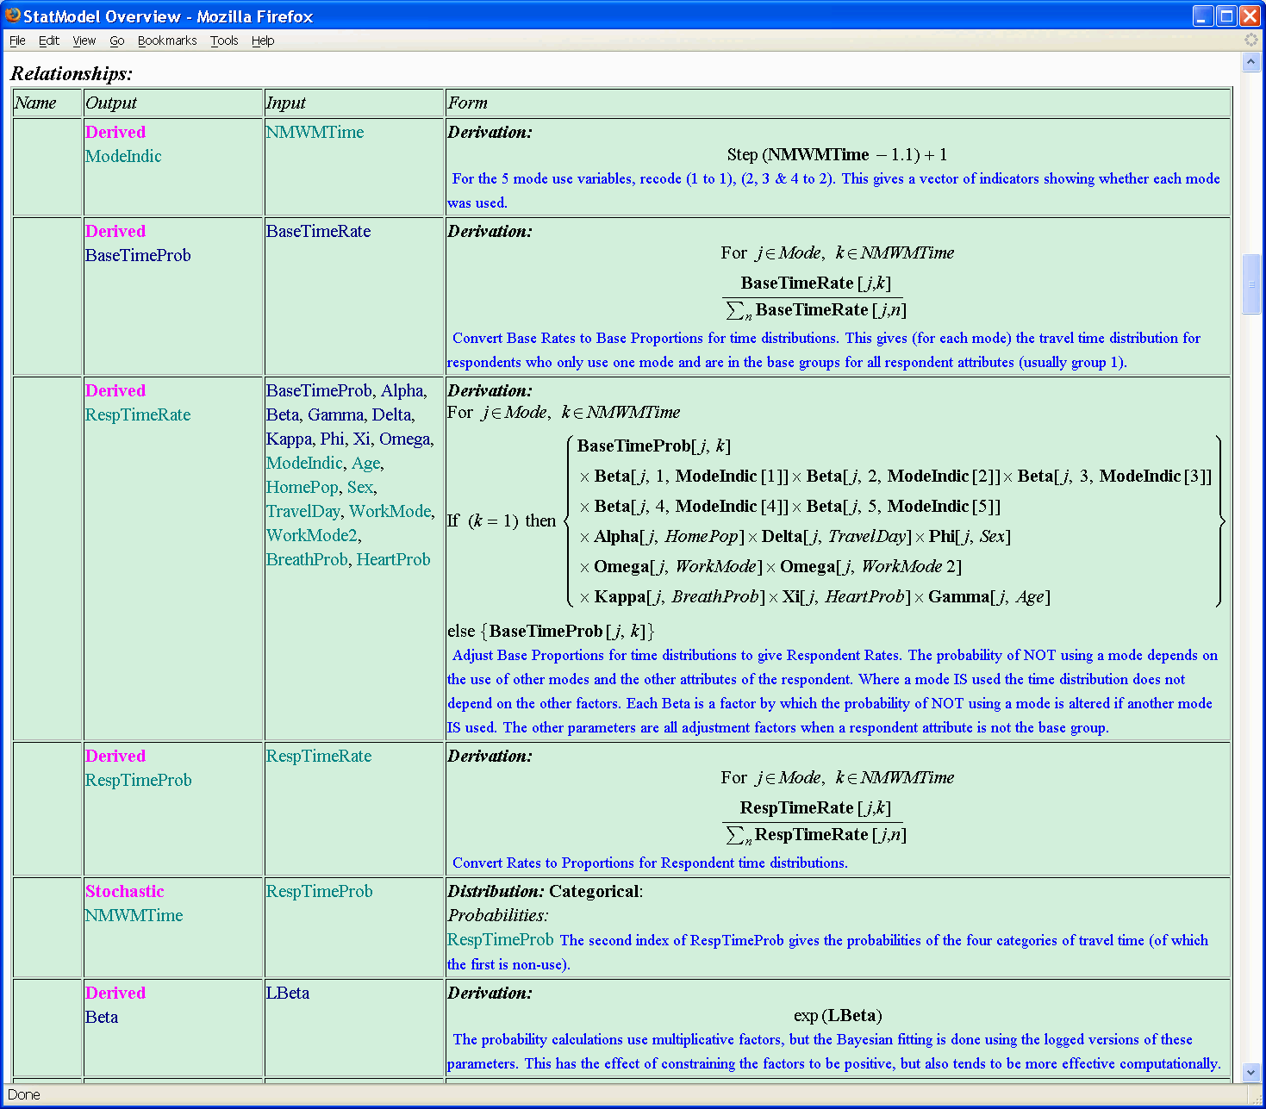
Figure 3. StatModel Listing (part)
The information presented by this listing is a complete presentation of the contents of the XML document, and is often adequate for exploration by the originator of the model and other specialists. It can be more helpful than the original script used in WinBUGS (the statistical application used for this example) for less experienced users, but in general a user will need more explanatory information and context.
For specific applications the style sheet can be used (by someone familiar with XSL/T) as the basis for a more focussed listing. However, this approach has limited applicability.

Graphical display of model relationships
Components have been developed to provide dynamic displays of parts of the StatModel instances within a web browser. Figure 4 shows the testing interface which is made available to partners and associates of the Opus project. This includes the full influence diagram for the model of which Figure 3 lists a part.
The display is a Java applet, and the graph is created dynamically from the information in the XML document. Controls are provided for a number of different automatic graph layout algorithms, the user can zoom and pan the display, and can select to manually adjust the location of individual nodes. Various graph trimming and filtering options are provided, and interesting sub-graphs can be pre-defined.
Colour coding is used to distinguish between variables (green) and parameters (blue) in the display, and the node shapes distinguish between derived, stochastic and other relationships. Constraints are shown in light grey.
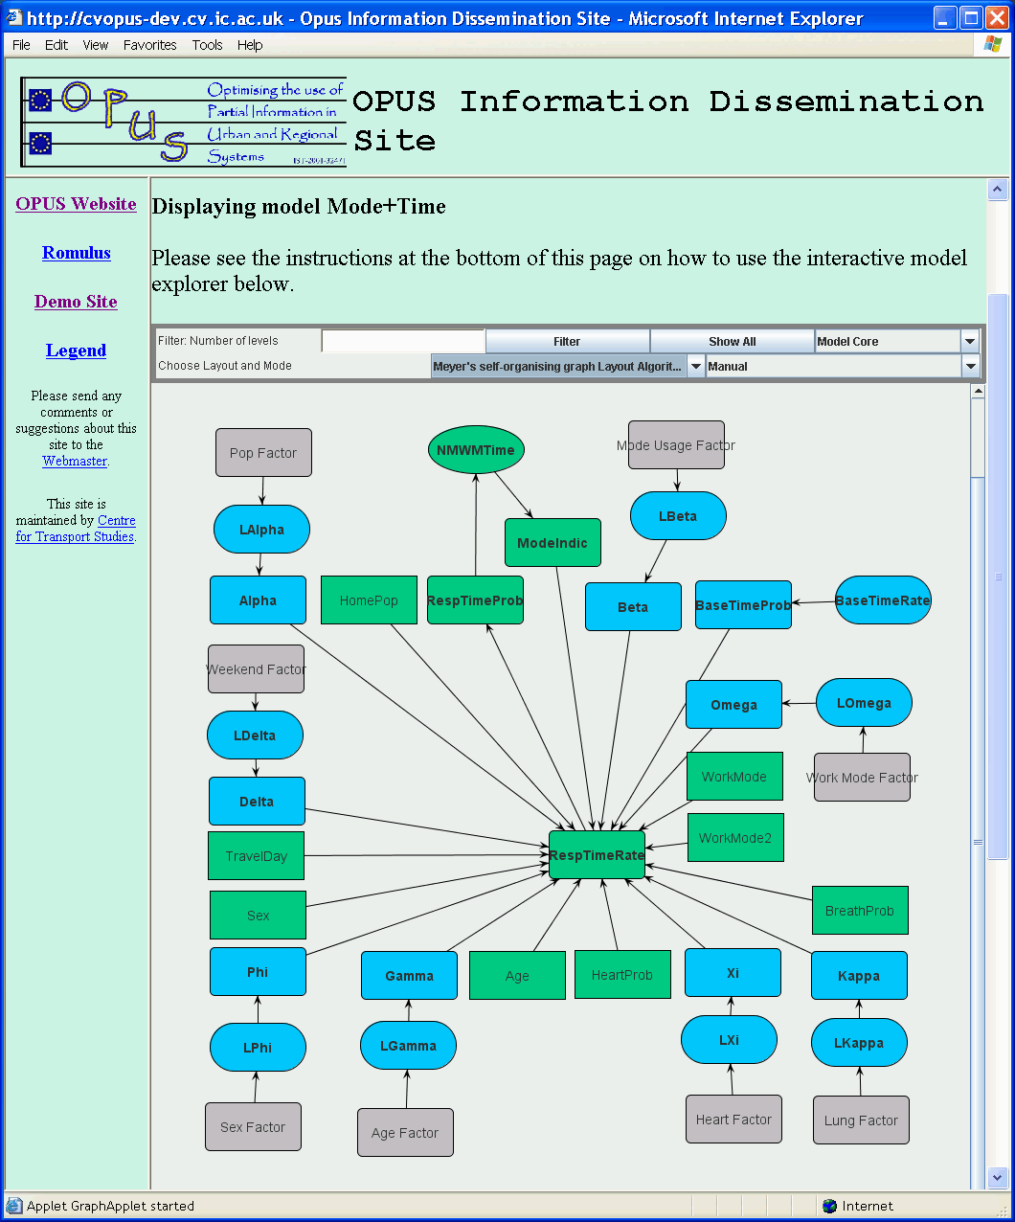
Figure 4. Full influence graph in browser
Figure 4 shows all the relationships in this model. The display is complex, but some regularity can be discerned, suggesting that the complexity comes from the number of elements, rather than the basic complexity of the model.
Figure 5 shows two sub-graphs. The left one extracts just the part that relates to the response variable in the dataset, the variable NMWMTime, which is a vector showing time spent on each of 5 transport modes, grouped into four classes. BaseTimeRate is an array giving the basic usage rates for each mode. This is a terminal parameter, indicated by the lozenge shape. These figures are standardised in BaseTimeProb and then adjusted in RespTimeRate to account for the characteristics of a data subject, including their mode usage. These rates are again standardised to give probabilities (in RespTimeProb) which are used in the stochastic relationship (indicated by an oval) to define NMWMTime. ModeIndic is a vector of derived indicators for whether each mode was used at all, which feeds back into the calculation of RespTimeRate.
The right-hand part illustrates how some of the covariates contribute to the calculation of RespTimeRate: Age selects a Gamma parameter, Phi relates to Sex, and Beta to Mode Usage. The mathematics of these relationships can be read from Figure 3.
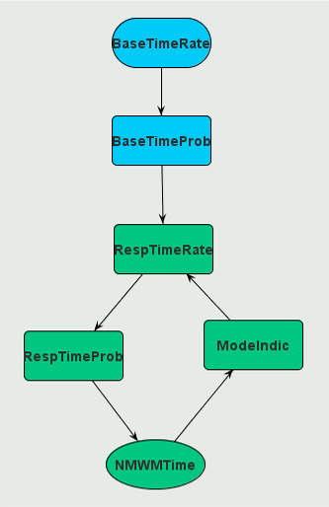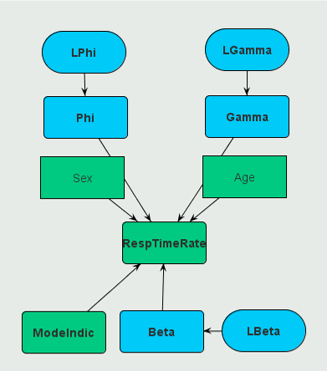
Figure 5. Sub-graphs

Comparison of models
The influence graphs can make it straight forward to see the differences between related models. For example, Figure 6 shows the graph for a log-linear model in which two independent estimates are used to calibrate a single model.
This example arises when two quite different methods (such as a household survey and roadside measurement) are used to estimate the flow between zones in a transport system, and a combined estimate of the parameters is desired.
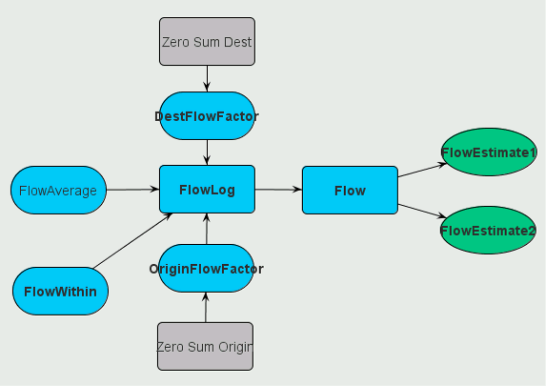
Figure 6. Model with independent estimates
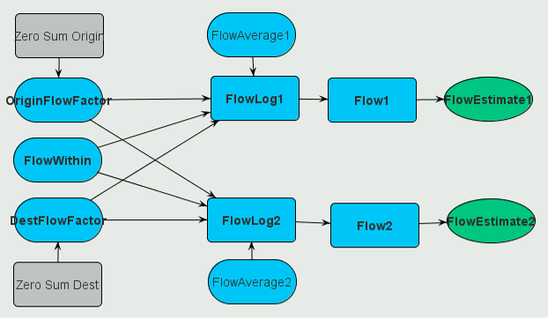
Figure 7. Model with differentiated estimates
Figure 6 treats the two estimates as independent samples from exactly the same stochastic process. In contrast, Figure 7 shows the model in which it is recognised that the two different data collection methods may influence the estimates.
Here the origin, destination and within factors are still shared, but it is recognised that the average level of flow obtained from the two datasets may have been influenced by different biases, so are estimated separately.

[1] Hughes, K., Jenkins, S. and Wright, G. The Triple-S Survey Interchange Standard: See www.triple-s.org
[2] Dublin Core Metadata Initiative. See dublincore.org
[3] UK GovTalk. e-GMS, the UK Government metadata standard. See www.govtalk.gov.uk/ schemasstandards/ metadata_document.asp?docnum=872
[4] IQML: Intelligent Questionnaire Markup Language. See www.epros.ed.ac.uk/iqml.
[5] QEDML: Questionnaire Exchange and Deployment Markup Language. See www.qedml.org.
[6] Kent, Jean-Pierre & Schuerhoff, Maarten: Some Thoughts About a Metadata Management System. SSDBM 1997.
[7] UML, the Unified Modelling Language. See www.omg.org.
[8] SDMX.. Statistical Data and Metadata Exchange. See www.sdmx.org
[9] DDI Alliance. Data Documentation Initiative. See www.ddialliance.org
[10] MetaNet: Network of Excellence for Statistical Metadata. See www.epros.ed.ac.uk/metanet
[11] Froeschl, Grossmann, Del Vecchio: The Concept of Statistical Metadata (2003), at www.epros.ed.ac.uk/metanet/deliverables/deliverables.html
[12] The Opus Project. See www.opus-project.org
[13] Nesstar. See www.nesstar.com
[14] Carlson, D.A. et al. hyperModel Workbench. See www.xmlmodeling.com
[15] Westlake, A. Provenance and Reliability: Managing Metadata for Statistical Models. In proceedings of 18th SSDBM, IEEE (2006) ISBN 0-7695-2590-3.
[16] Whittaker, J. Graphical Models in Applied Multivariate Statistics (1990). Wiley.
[17] MathML. See www.w3.org/Math
[18] Design Science. Math Player – display MathML in a browser. See www.dessci.com/en/products/mathplayer

Andrew Westlake has more than thirty-five years experience contributing to the design, implementation and management of statistical computing projects in university departments and international research organisations, and is a Fellow of both the Royal Statistical and the British Computer Societies, as well as an Honorary Member of the ASC. He has been deeply involved in software development for survey and statistical applications, and has gained an international reputation for the application of database methods to statistical problems. His research projects have involved work for statistical, demographic and health departments in academic, research and government organisations throughout the world, and have varied in scale from small sample surveys up to national vital registration systems. His current special interest is in the structural and metadata aspects of databases for aggregate statistical data and statistical models. He can be contacted through www.sasc.co.uk.

